Ethan Daugherty

SNHU

CS-360-H7255

2-2 Assignment: User Components and Data

03/13/2022

**User Components and Data**

Before beginning this assignment, you will need to select a mobile app that incorporates data for users to access in its design. This can be an app you are familiar with using or one you have found through online exploration.

Specifically, you must address the following rubric criteria:

* Discuss the features of the mobile app. After you have chosen a mobile app to analyze, briefly identify the app and explain its purpose. Then address each of the following:
  + Describe the app’s screens and features.
  + List the major UI components on each screen.
  + Identify where data is included in the app.

The mobile app I’ve chosen to explore is the YouTube App. It contains a few different screens that allow users to explore content sourced from other users. When first opening the mobile app user is brought to a home screen. The home screen displays videos that a user may be interested in along with buttons to mute the video and display close captions, tapping the video will enlarge the content and allow a user to explore more similar content and comments left by other users on the video. Additionally, along the top of the app there are buttons such as notifications button the app the allows a user to explore new videos other users have uploaded that you have subscribed to, a magnifying glass button that allows a user to enter queries into a search field and a profile icon button that allows a user to edit their personal details they’ve entered into the application.

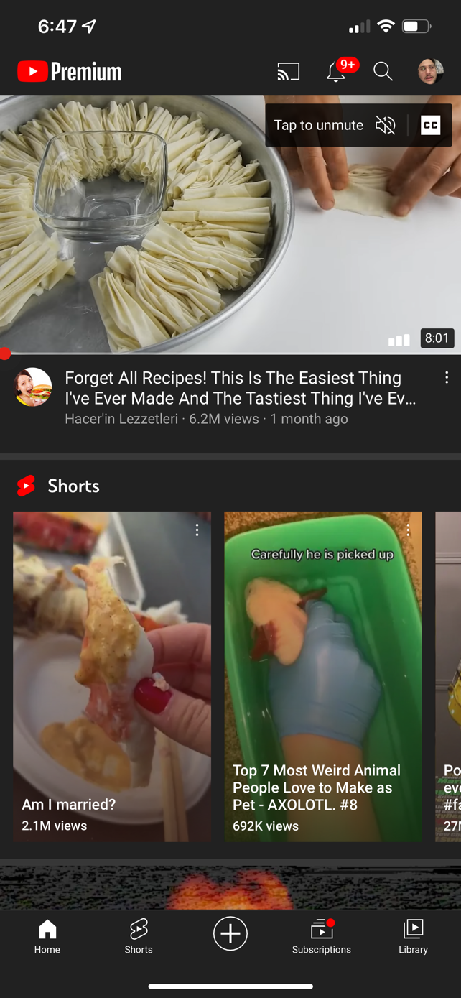

Figure : Top Half of Application



Figure : Bottom half of application

Exploring the bottom half of the home page gives a user a couple different button. There is a home button that refresh’s the apps home screen or returns the user to home if on another page. A shorts button that allows a user to explore videos other users have uploaded that are short in length, a plus button that allows a user to upload new content to share with other users on YouTube, a subscriptions button that displays videos from creators the user has subscribed to, and a library button that allows a user to explore their uploaded content, history, and videos a user may have favorited for easy retrieval or playlists to organize both theirs and other users uploaded content.

* Discuss the possible data sources of the mobile app. Determine what data each component of the app either displays or accepts as input. Then, think about where the data might come from. Note that sometimes it may come from external sources, and sometimes from users.

The data on the YouTube mobile app is all sourced from users uploading content. Users create content then share it online by uploading it to YouTube either on a computer or via the mobile application. The same content that is available online from a desktop computer is also available online on the mobile application. The exception to data that is sourced from end users is when YouTube shares commercially produced movies or television shows. This is content created by media studios that YouTube allows users to purchase or rent to view.

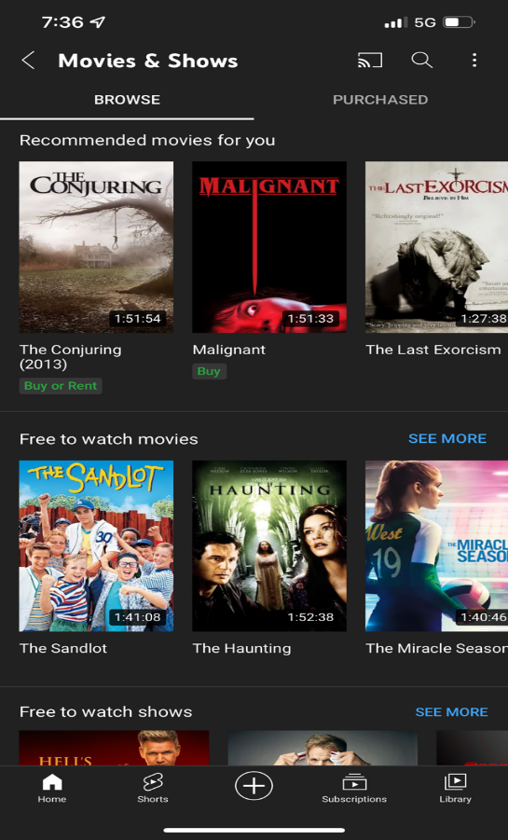

Figure : Content YouTube Allows users to purchase

* Explain how the data that users interact with helps them meet their goals. Begin by identifying what kinds of data users are interacting with in the app. Then, discuss how that data helps users meet a need. Think about how that data is being displayed and why that would be beneficial for a user.

The YouTube mobile application is used primarily to entertain, and users have a variety of ways to interact with not just the data uploaded on the application but additionally with other users to fulfill this need.

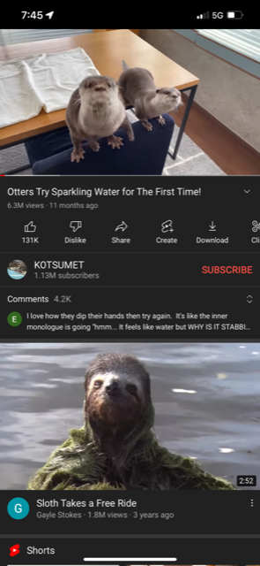

Figure : YouTube Application after opening a Video

To start users can press buttons that both like and dislike content, this information is public and available to other users and it helps content creators know what content users like and dislike out of the content that they have uploaded. Next the Share button allows users to send videos to other YouTube users via different communication channels. The create button allows users to take the audio or video from another clip and include their own content to create something new. Next, the Download button allows a user to save the video to watch later. Finally, the YouTube mobile application allows users to comment on videos to share their thoughts and interact with other users to entertain themselves.